How to set the default start diagram with PecView
1. When PecView is open for the first time, it starts with a black screen.

2. Right-click on the screen, select Operator Login… from the pop-up menu.
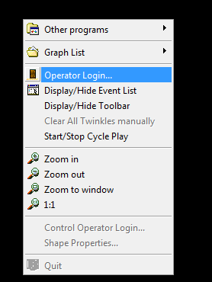

3. The Login window appears. Enter the correct User Name and Password that have the right of Change User Diagrams. The default User Name is ROOT, the Password is null. Click Ok.
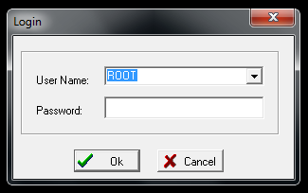

4. Right-click on the screen, select Display/Hide Toolbar from the pop-up menu.
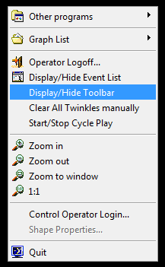

5. The toolbar is displayed at the bottom of the screen. Click Start Configuration System Options.
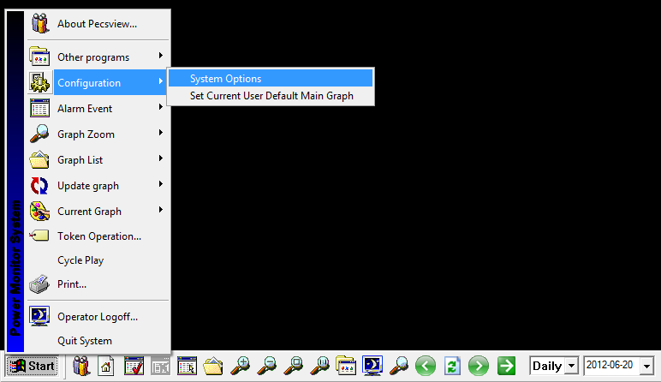

6. The System Properties window appears. From the Normal Properties tab, click Browse… behind the Main graph.
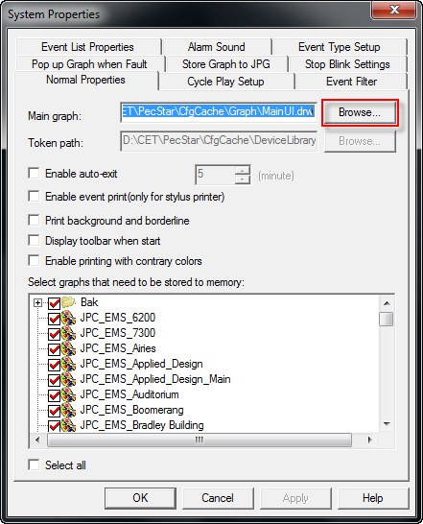

7. The Open window appears. Navigate to the folder and select the diagram that you want to set as the start diagram. Then click Open.
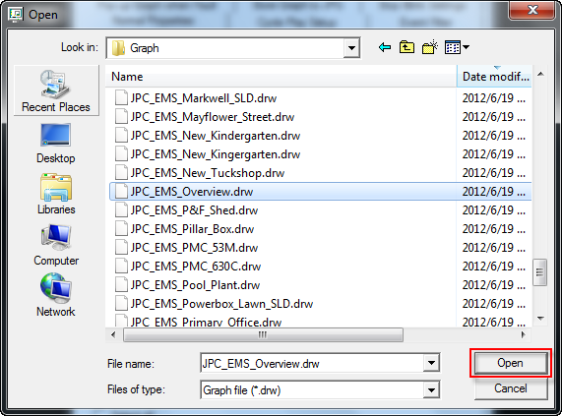

8. Then the selected diagram is shown in the Main graph box. Click OK.
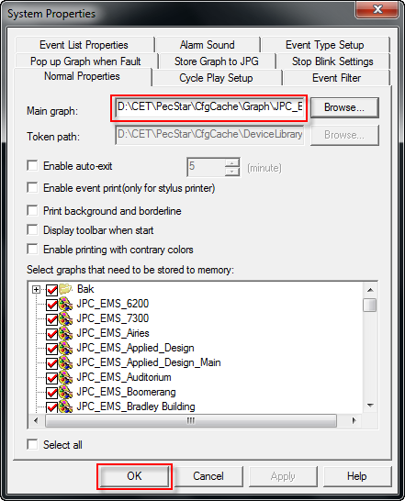

9. Right-click on the screen, and select Quit to exit PecView.
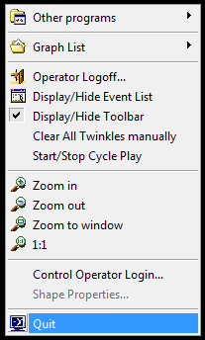
10. Restart PecView, then the screen will display the default start diagram.
